IT7742 - Assessment2 - Advanced Programming
Punit Beniwal (20230818)

Report - Design Rationale

I read the client scenario carefully. The client wants a small prototype to manage customer information. They want many kinds of user interfaces later (for web, mobile, whatever). So the design must be flexible and simple. They said the prototype should use MVC (Model-View-Controller). That means the model holds data, view shows data, controller handles logic between model and view.

I decided to build a class called CustomerController and its design is shown in below diagram:

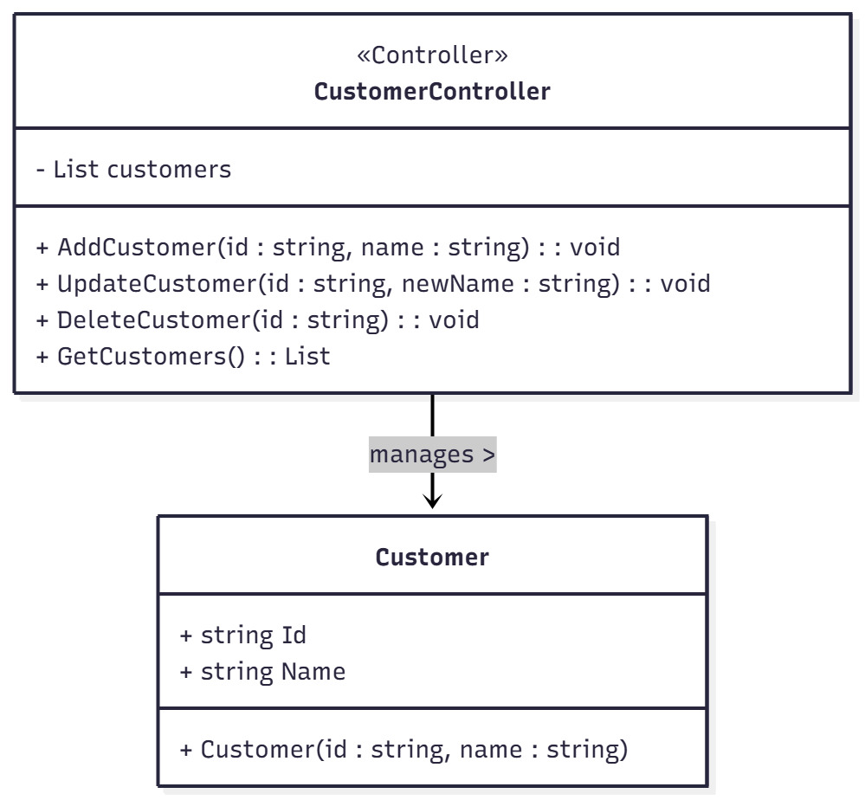

This controller class sits between the view (forms) and the model (Customer class). Its job is to hold a list of Customer objects and give methods to add new customers, update existing ones, delete customers, and fetch the list for display. The attribute is: List<Customer> customers. It is private. The methods are public:

- AddCustomer(id : string, name : string) : void — this method checks that id and name are not blank, then adds a new Customer object to the list.

- UpdateCustomer(id : string, newName : string) : void — this method finds the Customer in the list by id, then updates the Name property.

- DeleteCustomer(id : string) : void — this method finds the Customer by id and removes it from the list.

- GetCustomers() : List<Customer> — this returns a copy or view of the current list for the view to bind to a grid.

All these match the signatures in the UML above. The constructor of the controller initializes the list. The view uses the controller by calling these methods. Because the controller is separate, if the client later builds a web interface, they can reuse the same controller without changes.

This design meets the client requirements. The prototype supports basic operations (add, update, delete, get) and uses MVC. The model (Customer) only holds data—id and name. The view (Windows Form) only shows controls and passes user actions to the controller. The controller handles logic, data validation, and list management.

